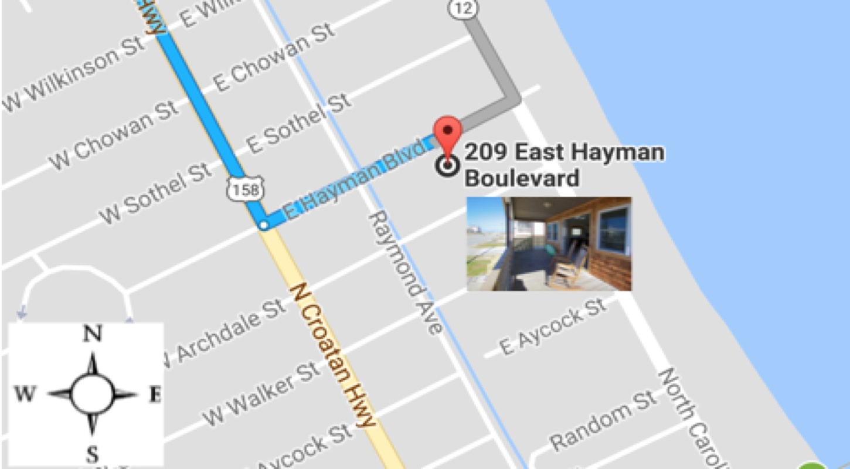
Welcome to the Insert Vacation Rental Name!
Insert Image of Google Map
Use Image of your Vacation Rental to mark location on map

Pro Tactic: Use Snagit to easily cut and crop images directly from your computer

Address: 123 Road, City, State, Zip
Access Code: [If Applicable or include how to access rental]

Feel free to reference the Arrival Map and Live Swell Beach Bungalow Prep Guide emailed to you to get an idea of what restaurants and stores are on your way into the Outer Banks as well as what is near your bungalow.
[Use if you have a Pre Arrival Guide]

Check in: After 3PM Check Out: Before 11AM (Unless otherwise agreed upon)

Parking
The Bungalow has a driveway and there are also public parking spaces along Hayman Blvd that you can use as well. Please do not block or park in any neighbor’s driveways. That being said if someone is in or blocking the Bungalow driveway or you do not have enough space for your cars, just give us a call or text at 123.456.7890
[Insert your parking instructions here or feel free to use a version of ours]

When you arrive at the Bungalow:
[Insert best way to enter the property]
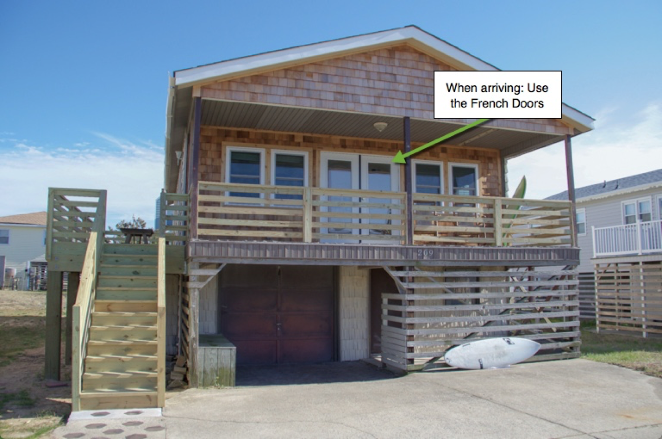
Insert Image of Property

Pro Tactic: Use Snagit to show best entrance on image
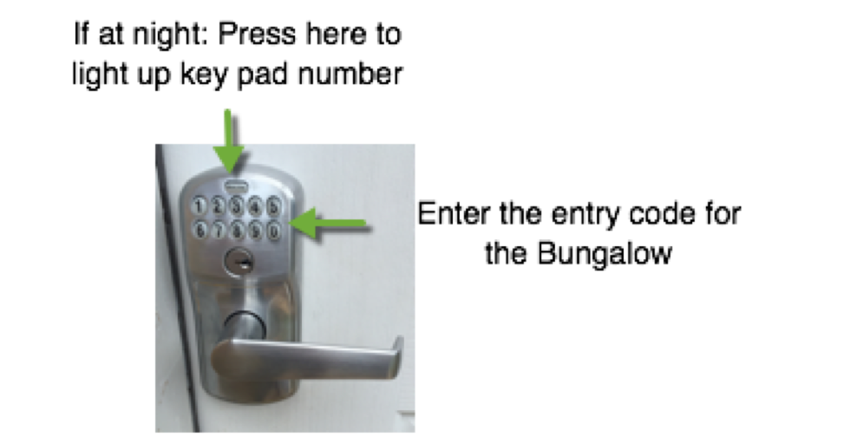
Next you will use the keyless entry keypad to enter the Bungalow:

[Insert any helpful entry details, if you use the Schlage lock like us, feel free to use our image!]

Magical Bungalow Code: 1234
Downstairs Code: 1234
[Section for codes or specific key info]
Any Questions: Call or text:
Maria: 123.456.7890

Your Logo or Vacation Rental Name

You are one step closer to your beach vacation with

[Insert helpful arrival details - we have attached more vector images so you can personalize to your rental]
Here are some helpful details for your arrival:
We provide:
Linens and Bath Towels
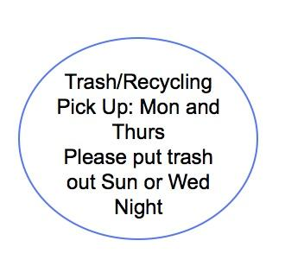
To get your started, we have provided one roll of paper towels in the kitchen and couple rolls of tissue paper in the bathrooms
Pro Tactic: Create image of trash pick up and enter here
Cable - Found in living room
Internet – Network: xxxxxxx Pw: xxxxxxx
If your run into any trouble with cable or internet, make sure all plugs are plugged in correctly and reset cable or modem if needed
Kitchen: Stocked with most essentials and basic cooking supplies
Coffee – A regular coffee maker is on site

Located in Downstairs Area: 4th Bedroom and Downstairs bathroom
Laundry: There is a washing machine and dryer in downstairs area
2 bicycles with 1 lock and some other beach items for your use
Gas Grill Onsite – sometimes stored in downstairs area to protect from weather
Beach Items: Beach Cart so you don’t have to leave any beach gear behind! Items include – Boogie boards, umbrella, a couple beach chairs, surf boards - Learning to surf? Check out Mike’s Surf Lessons - Click here
Suggested Items to bring:
The bungalow is stocked with most essentials; we suggest bringing any items that are important to you and your trip.
[Insert helpful items to bring - we have attached more vector images so you can personalize to your rental]
Spring/Summer
- Beach Items – We have some items on site, like boogie boards, beach cart, chairs, umbrella and you are welcome to them, we suggest bringing any EXTRA chairs, toys, towels, blankets, umbrellas etc to make sure you have all you need for your entire group
- Sunscreen and Aloe – We try to always leave some on site, but hey, it is the beach and no wants a sunburn
- If you are sensitive to mosquitos. There are bugs in the banks! Bug Spray! Bug Spray! Bug Spray!
Fall/Winter
- Be sure to pay attention to the weather. Fall and early winter bring some beautiful days to the banks, perfect for a beach vacation when it’s not so busy!
- Cooler temperatures mean less crowd and less bugs! Oh and tons of great fall festivals too!

We love helping to facilitate a 5 star guest experience! If during your stay, it’s anything less, contact us, we want to know so we can do our best to fix it :)

Maria: 123.456.7890

